Interpreting Windows NT Processor Queue Length Measurements

Yiping Ding, Debbie Sheetz, Yefim Somin
BMC Software, Inc
Yiping_Ding@bmc.com, Debbie_Sheetz@bmc.com, Yefim_Somin@BMC.com

Ethan Bolker
BMC Software, Inc
University of Massachusetts, Boston
eb@cs.umb.edu

William Flynn
University of Massachusetts, Boston
wdf@cs.umb.edu

Processor Queue Length is one of the metrics Microsoft Windows (NT, 2000, and XP) maintains in its registry. Observed values often contradict expectations about how queue length should correlate with system load (e.g., utilization) and transaction response time. In this paper we examine data from several experiments performed on Microsoft Windows. The results led us to conclude that measured processor queue length is of little use in understanding Windows NT system performance from an application point of view.

Introduction

With sufficient dedicated resources, transactions can complete in a time that depends only on the actual amount of work they need to do and the time it takes for the resources to do the work. But sufficient dedicated resources are always too expensive. The art of system design lies in building a configuration in which when transactions must wait for what they need, they need not wait too long. So the key to good performance in a constrained environment is understanding queueing delays (time spent waiting) and exercising appropriate control of them according to performance objectives. Queueing delays are essentially proportional to queue lengths – so measuring and predicting queue lengths is a cornerstone of good capacity planning and performance modeling. But you can’t usually measure queue lengths yourself – you must rely on what the operating system is willing to provide. Most try to be helpful, but measuring queue lengths accurately and objectively is difficult. Queue lengths vary rapidly as state changes in the operating system and user transactions and system threads come and go at random times or in a correlated or synchronized fashion. And the running measurement software itself is a part of the system being measured. In order to use queue length measurements wisely you must understand their semantics both in theory and in practice. This paper shares our recent unsuccessful attempts to reconcile measured Windows NT processor queue length with theoretical and empirical predictions for idle systems and for systems subject to controlled loads

1. Utilization and Queue Length

Our story starts with an observation we made on an idle Windows NT system. We watched the measured queue length oscillate around 4 while the processor utilization hovered near 0. Figure 1 shows a typical set of values for the metrics %Total Processor Time and Processor Queue Length collected by Microsoft Performance Monitor, a utility provided as part of Windows NT.

Windows maintains values for these metrics in its Performance Registry. The NT Performance Monitor samples the values once a second and updates the displayed chart in real time. It automatically scales the small integer value of the Processor Queue Length by a factor of 10 so that it can be seen at the same time as the %Total Processor Time, which is in the range 0-100.

To see what these measurements mean, we consulted Microsoft’s documentation.

%Total Processor Time is the average percentage of time that all the processors on the system are busy executing non-idle threads. On a multi-processor system, if all processors are always busy this is 100%, if all processors are 50% busy this is 50% and if 1/4th of the processors are 100% busy this is 25%. It can be viewed as the fraction of the time spent doing useful work. (see Performance Monitor on line reference [PERFM])

In NT no physical processor is ever really idle. When one has no real work to do, it executes a thread in the idle process. So to compute “%Total Processor Time” the operating system can sum the time that the N processors spend executing a thread of the idle process during the sample interval, subtract that value from N × (sample interval length) and divide the difference by N.

It’s important to observe that %Total Processor Time is an average value representing system behavior over the most recent one-second sample interval, not an instantaneous value at the time the sample is taken. An instantaneous value would have to be at least 1/N since at the time the observation is made at least one processor is busy making the observation!

Processor Queue Length is the instantaneous length of the processor queue in units of threads. … All processors use a single queue in which threads wait for processor cycles. This length does not include the threads that are currently executing. … This is an instantaneous count, not an average over the time interval. [PERFM]

So unlike Processor Time, the Processor Queue Length is NOT an average at all. (Note: This is not the case for most UNIX platforms where queue length measurement counters are maintained continuously.)

2. Measurement Anomalies

The same documentation continues with the warning that “a sustained processor queue value of greater than two threads generally indicates processor congestion”. Windows 2000 Performance Guide [FRIED02] echoes a similar warning. But that’s not true here. The processor in our idle system with a sustained processor queue length of four is not congested: it’s busy only about 2% of the time.

Moreover, that non-zero queue length would be suspicious even without this spurious warning from Microsoft. An average CPU utilization of 2% implies that if you look at the CPU at 100 randomly selected times you will see it working on something useful (i.e., busy executing non-idle threads) just twice on average. The other 98 times there can’t be any threads on the processor queue – since if there were ready threads they would run, not wait. But we seem never see a queue length of 0. So where do the four threads on the processor queue come from? If they are really waiting in the queue, why isn’t the idle processor assigned to work on them?

Busier systems also show anomalous queue lengths. Figure 2 is a Performance Monitor trace for a period when a different NT system did some transient work starting a browser. There is a tenuous visible correlation between the CPU utilization and the queue length in the left third of the figure, when the CPU utilization spikes to 45%, 60% and 75%. About all we can say about the figure as a whole is that the average value of the instantaneous queue length metric is about 7.5 while the average CPU utilization is about 9%.

There is a simple formula from queueing theory that describes the relationship between utilization U and queue length Q under some assumptions about the degree of randomness of the demands made on the system. When those assumptions (a random observer watching a system with random transaction arrivals) are satisfied we expect

Q = U/(1-U).

In Figure 2, U = 9% = 0.09, so we should see Q = 0.09/0.91 = 0.1. In this formula Q counts the job in service as well as those waiting, so to compare it with the value NT reports we should subtract that job, which is actually present about U = 9% of the time. Thus our theory predicts an NT processor queue length of 0.1 – 0.09 = 0.91. That is almost an order of magnitude less than the observed 7.5. It’s even half an order of magnitude less than 7.5 – 4 = 3.5, which is what might try as a first order correction, subtracting the unexplained spurious 4 we observed in the idle system. So we have yet another indication that something is wrong or counterintuitive.

In theory, it is possible to have a large queue length with low utilization, if the activity is very bursty (i.e. there is a high coefficient of variation) or the activity is synchronized (or highly correlated) with the sample observations. We will examine those possibilities in later sections.

3. Some Hypotheses

We first checked the definitions that determined which threads are counted in computing the Processor Queue Length. At each stage in the life of a thread it is either actively consuming resources (CPU, disk, network, etc.) or waiting for them. According to Microsoft documentation [PERFM], the Processor Queue Length is the number of threads in state 1, where the 7 possible states are:

0: initialized.

1: ready. A ready thread wants to use a processor but is waiting because none is free.

2: running. A running thread is one using a processor.

3: standby. A standby thread is about to use a processor.

4: terminated.

5: wait. A waiting thread has no use for a processor because it is waiting for a peripheral operation or a resource to become free.

6: transition. A thread in transition is waiting for a resource in order to execute, such as waiting for its execution stack to be paged in from a disk.

7: unknown.

We see no reason to doubt the assertion that the Processor Queue Length is sampling the field in the System object in the NT kernel that tracks the number of threads in state 1. In fact, we confirmed this interpretation by implementing our own independent measurement software.

Our next line of attack in trying to reconcile the numbers was to examine the hypotheses implicit in the queueing theory model, which when U = 0.02 predicts Q = 0.2/(1–0.2) = 0.2 instead of the 4 we observed.

One assumption in that formula is that the times between thread arrivals at the CPU and the service times for each thread are essentially random – more precisely, that they are exponentially distributed. If they are not, the coefficient of variation enters the formula, which can be found in standard references [KLEIN76][KANT92]. If the more general formula is to predict the measured queue length, the coefficient of variation for either service time and/or interarrival time must be approximately 200, instead of the 1 for the exponential distribution. That would require extremely bursty behavior of the threads in the NT system. It was also suggested that there might be clustered arrivals of many very short requests (threads using very little CPU) followed by a very long idle periods in which would result in low average utilization. But were that the case, we would expect to see, instantaneously, rare high peaks and long low valleys for the queue length. Neither Figure 1 nor Figure 2 shows that to be the case.

4. What Does “Idle” Mean?

We have been trying to resolve two logically contradictory notions: “idle system” and “non-zero queue”. Our naïve assumption is that if a processor is idle most of the time, then its queue should be empty most of the time as well. In fact, in the queueing modeling literature, an idle period is often defined as an interval with an empty system. An idle (or almost idle) system with a constant queue length of four is counterintuitive. We think we can explain the apparent contradiction.

From a business or application software perspective, a computer is idle when it is not doing work that generates revenue – think of a transaction processing system configured to respond to users requests. It’s idle when no requests are being processed.

But from the system’s perspective, it’s not idle even then. The operating system must run, data collection software must run, and even the software that’s waiting for real work to do must run to see if it can stop waiting and do something useful. In Windows NT, if there is absolutely nothing for the processor to do, it runs the idle thread!

Figure 3 shows the list of running processes NT’s Task Manager reports for our idle system, sorted by current CPU usage. There are 43 active processes, even though only the Task Manager itself is consuming enough CPU to show given the 1% granularity with which CPU utilization is presented. MSOFFICE.EXE is active, even though no office applications are open. Watching idle systems on this and other machines, we discovered that the only significant consumers of resources were often:

- (1) The performance monitoring software
- (2) The virus scan
- (3) Winamp and Realplayer

The first of these is no surprise. System management has a cost. It’s small but unavoidable. Fortunately, although its cost grows as the system load grows, it does not grow in proportion.

The second, representing security in general and virus protection in particular, is a necessary cost of doing business on the web. But it does suggest that a default configuration, which scans and watches continuously, may use more processing power than is needed to protect the machine in the particular environment in which it is operating.

The third is a cost you may not want to pay. Consider configuring your servers so that they boot without honoring Microsoft’s assumptions about what every desktop needs.

When we disabled the virus scan, Realplayer, and other inessential services, both measured queue length and processor utilization decreased. But the measured queue length was still almost always at least two. So our philosophical puzzle remained.

5. Synchronization

Many of the active processes on an idle machine do in fact do a little work. They wake up from time to time to see if there’s a call for their services, and that polling takes some CPU. The windowing system itself polls to find out where the mouse is, and queues requests that will be acted on by applications when they wake up to examine that queue. If four of these processes happened to poll on the same one-second cycle as the Performance Monitor itself, we might see a Processor Queue Length that was always at least four.

To test that hypothesis, we changed the sampling frequency of the Performance Monitor – and found new surprises. Figure 4 shows the result of one of our experiments. At the left edge of the screen the Processor Queue Length oscillates fairly regularly between 1 and 2. That’s an improvement (so to speak) over the value of 4 we are used to. When we changed the sampling frequency to 0.5 seconds the average queue length began to oscillate around the value of 5. Just for fun we resized the window to watch the spike in CPU utilization. Then we changed the sampling frequency back to 1.0 second – and the Processor Queue Length started oscillating around the value 4. It seems that whatever the steady state measured queue length is, it depends upon some initial conditions.

In a vain attempt to guess what was happening, we tried many experiments of this kind. We set the sampling interval to values that we hoped might miss the hypothetical polls of other applications, in hopes of seeing mostly 0 for the Processor Queue Length. We tried long and short sampling intervals. What we observed was that after almost any action e.g. changing sampling frequency, causing some kind of spike by exercising another application or resizing the window, minimizing the window and then restoring it) the Performance Monitor reported a Processor Queue Length that oscillated in some almost periodic (and quite hypnotic) pattern about a value somewhere between 1 and 6, 4 more often than not. Figure 5 shows another example. Sometimes restoring the Performance Monitor window from a minimized state seemed to increase the visible processor queue length. That might be because restoring the window increases the priority of the Performance Monitor application, allowing it to run ahead of some other ready jobs, which it could therefore see on the queue. In general we were unable to predict the value of the Processor Queue Length, despite spending much time speculating. If we cannot predict the queue length by observing the relationship between utilization/activity and queue length, performance tools certainly cannot predict it “correctly”, either.

But we did convince ourselves that some kind of synchronization causes the anomalous queue lengths when utilization is low. It’s unlikely that all the active processes are sampling synchronously. Our experiments support that proposition, since we tried many sampling frequencies. We suspect instead that the synchronization is introduced by the operating system code that updates the System object in the Registry that the Performance monitor queries to report its results:

- At every sampling clock tick the System object in the Registry thinks there are threads ready to run. Which threads these are depends on the behavior of some active but essentially dormant processes that wake up periodically to poll for work to do.
- What the System object in the Registry thinks may not always accurately reflect reality. These threads may not actually be on the queue of ready threads.
- When these threads do actually run they are short lived, consuming very little CPU.

If the above scenario were correct, it would explain the constant queue length at some value between 2 and 6 seen on idle NT systems.

We performed similar experiments on a few Windows 2000 and Windows XP systems. Each of those operating systems maintains the same two counters of interest in its registry, and provides a tool much like Performance Monitor to view the data from the registry. In both systems we found similar anomalies, but they seemed much less severe. Queue lengths seemed to vary between 0 and 2 rather than between 2 and 6, and spikes correlated as expected with system activity. Figures 6 and 7 show some sample screen captures.

There are multiple potential causes of measurements inconsistencies related to threads and interrupt behavior, as pointed out in [[FRIED02, p. 131]. Only Microsoft could determine for sure the mechanism leading to this situation. The authors have contacted Microsoft, but there was no conclusive resolution of the question at the press time.

6. Busy System Benchmarks

Although we have concentrated so far on understanding idle systems, we are really interested in busy ones, where we hope our queueing theory models can be used to predict queue lengths and hence response times. That might be true if the anomalies we observe at low utilizations turn out to be just low-level noise, swamped by real data.

To that end we ran a sequence of benchmark experiments, generating an artificial load on the system. At random times a client machine elsewhere on the network generates a request for a random amount of server processing. A daemon running on the server responds to those requests by launching a CPU-intensive job. The randomness of the interarrival times and service demands is exponential, a choice that often models real transaction processing systems reasonably well and allows us to compare the measured queue length with the prediction from simple queueing theory, where that particular kind of randomness is well understood.

The NT measurements were collected with a commercial performance analysis tool that queried the same NT Registry data structures used by Performance Monitor. This package sampled at 5 minute rather than one second intervals and did no display, so its overhead contribution to system load was much lower than Performance Monitor’s. In addition, the benchmark software itself tracked processor utilization and transaction response time.

Table 1 shows the observed CPU utilization, average observed Processor Queue length and the queue length predicted by theory at three utilizations. The good news is that observed queue lengths do not seem as far out of line as in idle systems. We see a value greater than 4 only when utilization exceeds 25%. The bad news is that although the observed queue lengths trend as expected, their actual values are not well correlated with the predictions

Table 1. Benchmark results

CPU utilization | Observed queue length | Theoretical queue length
15.49% | 2.01 | 0.18
28.63% | 4.62 | 0.40
72.73% | 9.65 | 2.67

To further explore the possibility of a systematic connection we looked at the benchmark data reported for the 5-minute subintervals. We found nothing useful. The erratic numbers in Table 2 show why.

Table 2. Benchmark results: selected 5-minute intervals from high utilization benchmark (Figures 8 and 9).

CPU utilization | Observed queue length | Theoretical queue length
39% | 4.50 | 0.63
50% | 6.22 | 1.00
55% | 6.16 | 1.22
73% | 9.57 | 2.70

Note that as a first order of approximation, we might subtract 4 (or some minimum constant queue length) from the observed queue length when the utilization exceeds 25%. That will make the theoretical queue lengths match the observed ones better, although not well (Table 3). But we need more compelling reasons to justify that kind of ad hoc data massage. Our idle system experiments show that there is no good way to choose a constant.

Table 3. Benchmark results after the observed queue lengths of Table 2 are adjusted.

CPU utilization | Adjusted Observed queue length | Theoretical queue length
39% | 0.50 | 0.63
50% | 2.22 | 1.00
55% | 2.16 | 1.22
73% | 5.57 | 2.70

Conclusions

To most performance analysts operating systems in general and Windows NT in particular are “black boxes” and should be. In order to use the measurement data they offer us we must understand that data so that we can translate it into terms that users and performance analysis tools understand. We can hope to do that by observing the system, studying documentation, comparing measurements with theoretical models based on our understanding of the system, and, as a last resort, opening the box. Using these tools, here is what we can conclude about the Processor Queue Length on NT systems:

- The statement in Microsoft documentation (and similarly repeated in some third party literature) that a “processor queue value of two threads generally indicates processor congestion” is inaccurate and misleading. That statement would be true if the reported Processor Queue Length were really a random sample of what was happening on a machine being accessed at random times by application software.
- A sustained processor queue length of greater than four threads generally indicates that a single processor is doing some real work, although such a value does not necessarily indicate a performance bottleneck.
- Inconsistent behaviors in queue length measurement have been demonstrated in both casual and controlled experimental conditions on Windows NT, 2000 and XP. The inconsistencies are much more significant on NT than on the other two more modern operating systems.
- The behavior of the measured Processor Queue Length may be explained by unknown and unavoidable quirks in CPU scheduling and in the registry mechanism itself.
- Since whatever those quirks are, they are essentially synchronous, so queueing models cannot be used directly, at least not without drastic modifications, to model or predict the Processor Queue Length as defined by Microsoft and reported in the Windows’ Registry.
- And there is no motivation to do so because there seems to be no systematic way to use the measured queue length values to assess system performance. We recommend that they be ignored for this purpose. For instance, we should not use the measured queue length and thread throughput to estimate the thread response time with Little’s Law.

References

[PERFM] On line reference for NT Performance Monitor. (To access Performance Monitor online reference, click Add to Chart ("+" tool icon) and then "Explain>>" button. The description for the selected metric will appear at the bottom of the pop-up menu.)

[FRIED02] Mark Friedman and Odysseas Pentakalos, “Windows 2000 Performance Guide,” O’Reilly, 2002

[MDN02] Microsoft Developers Network personal communications.

[KLEIN76] L. Kleinrock, “Queueing Systems, Vol. 2, Computer Applications,” John Wiley, NY, 1976

[KANT92] K. Kant, “Introduction to Computer System Performance Evaluation,” McGraw Hill, 1992.

[COCK98] Adrian Cockcroft, “Unix CPU Time Measurement Errors,” CMG98 Proceedings, Anaheim, 1998

Appendix. Benchmark Setup

Benchmarks were run in a client-server environment. The machine to be benchmarked is the server. A client machine schedules work on the server.

The client is a Java application that generates requests for service. A Perl daemon running on the server listens on a specific port for client input specifying a command to run by forking and opening the command as a named pipe. The daemon logs the command line, output from the command, and timestamp data.

In our experiments, the command run by the benchmark server is a small program that loops over a trivial CPU instruction (toggling a register value between 1 and 0) for a specified number of iterations. The number of iterations is calibrated so that we know how long they would take to execute on an otherwise idle machine. Timestamps are generated before and after the loop, to measure actual elapsed time and hence server queueing delays.

The client-side Java application is told the average interarrival time and the average service time for the jobs it will send to run on the benchmark target machine. It chooses interarrival times and service times independently from exponential distributions with the appropriate means. By manipulating the input arrival rate and service duration, a desired average load can be placed on the CPU of the target machine.

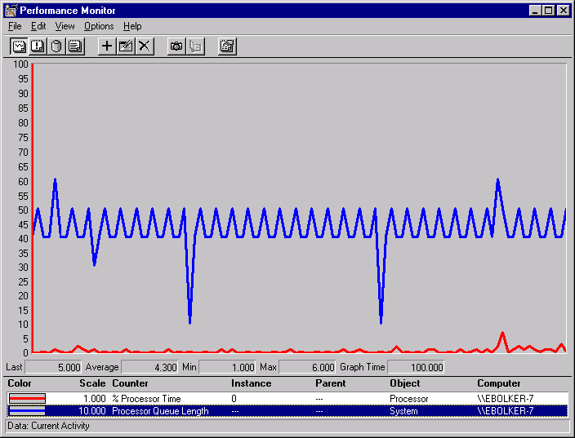

Figure 1 Typical behavior of Processor Queue Length on an idle system

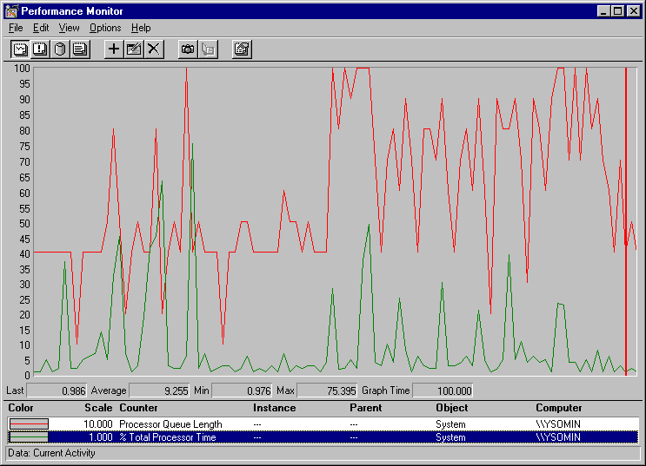

Figure 2 Transient work behavior of Processor Queue Length
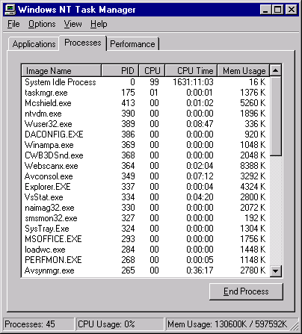

Figure 3 List of running processes

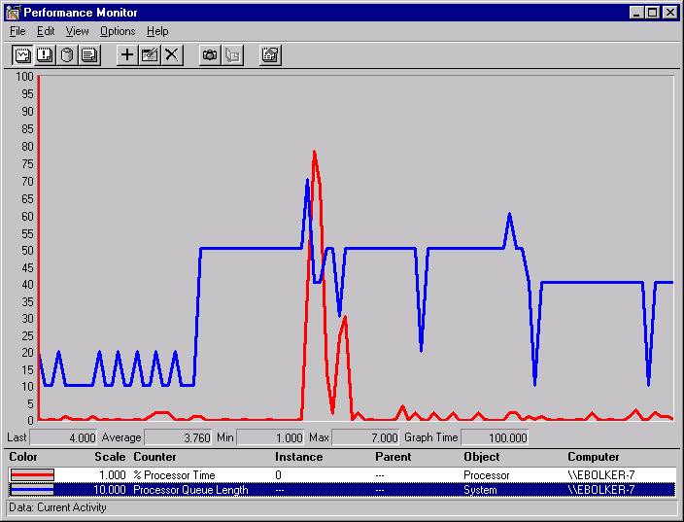
Sampling interval
---1.0 sec--------------0.5 sec-------------1.0 sec-
Resize window

Figure 4 Changing PerfMon sampling interval

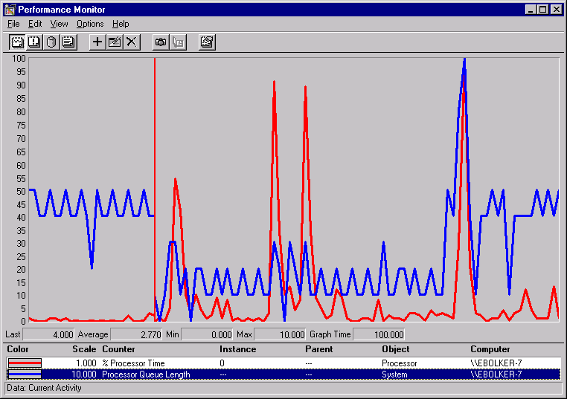

Figure 5 Impact of transitory disturbances

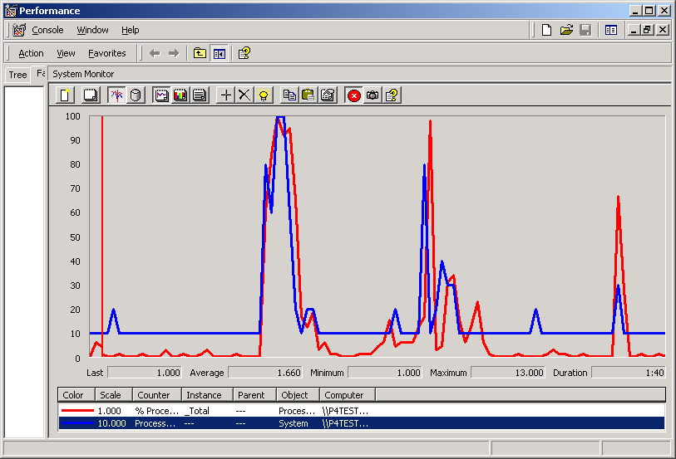
Random background processing

Figure 6 Windows 2000 behavior

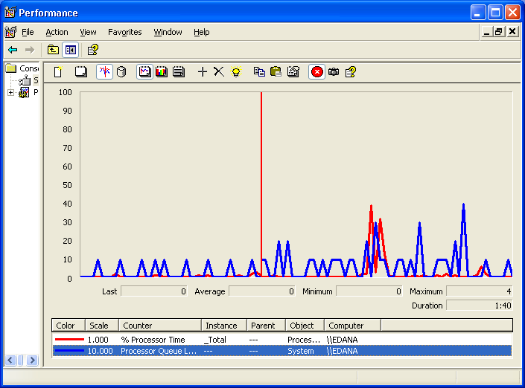
Minimize Task Manager
Start Task Manager

Figure 7 Windows XP behavior

Figure 8 Busy System Benchmark – CPU Utilization

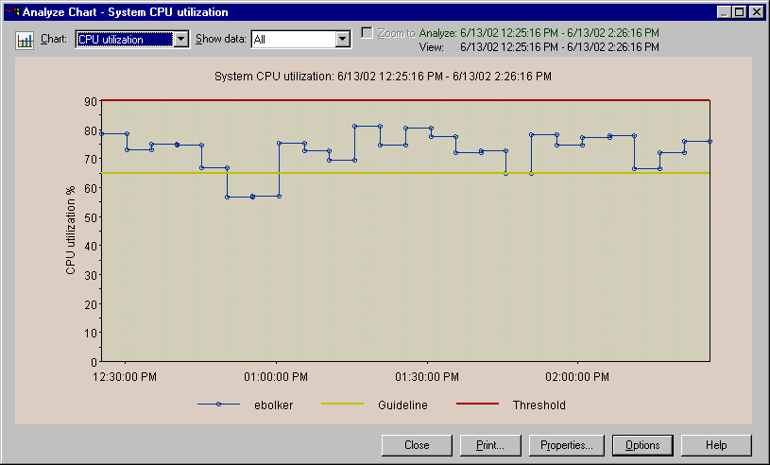

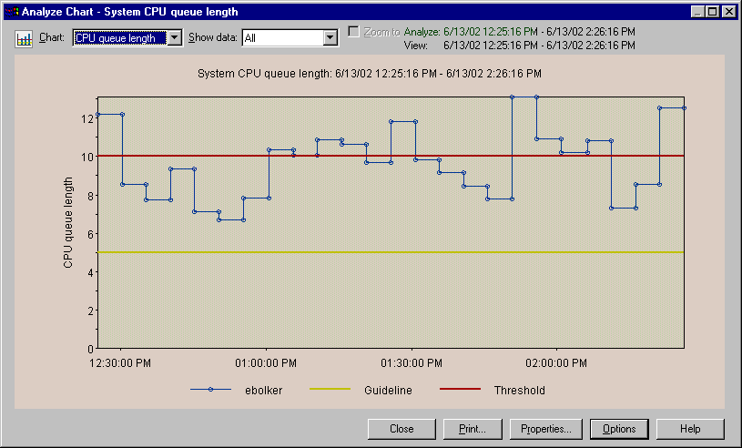

Figure 9 Busy System Benchmark - Processor Queue Length

Most people don’t care how an idle system behaves. But performance metrics are our hobby as well as our job, so we look at them all the time.
The naïve assumption is that all software systems should protect themselves from all possible errors. But that means that often clients and servers each make the same expensive checks. When the contract between client and server is well written and enforceable the check need happen in only one place.
It is interesting to note that a somewhat similar situation was described for Solaris OS by Adrian Cockcroft [COCK98]. One notable difference would be that on Solaris these sneak requests would not be pre-populated on the queue and hence not produce such a queue length measurement anomaly as in the Windows NT case.

