CS105 Homework Assignment 3
Due 11:00 AM, Dec 7 2011.

- Watch the video
http://video.google.com/videoplay?docid=-1508211417393454786#

Write a paragraph (about 200 words) discussing search engine.
Some pointers: (suggested but not limited to:)
- Think about why google (the search engine) is so popular
- What do you think about the work environment at google (the company)?
- How do search engines work?

- Why is natural language comprehension a hard problem for a computer?
3. Answer the following questions according the tables.
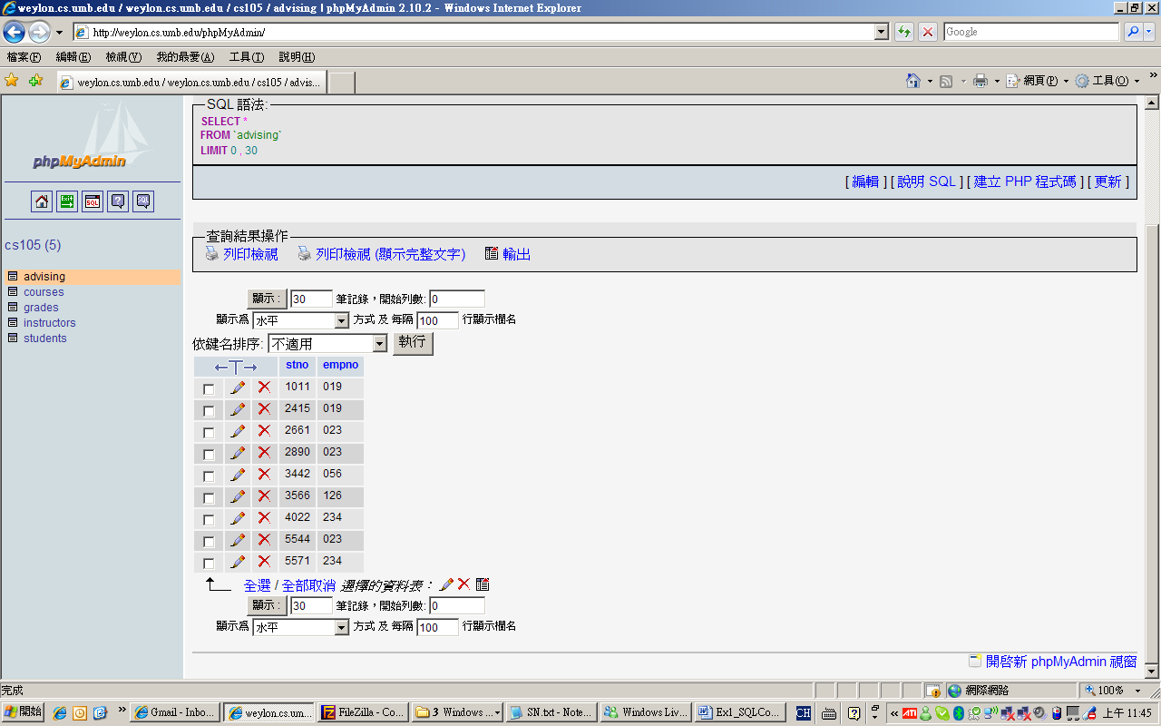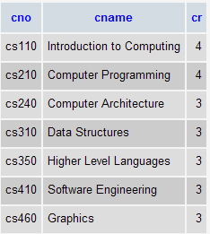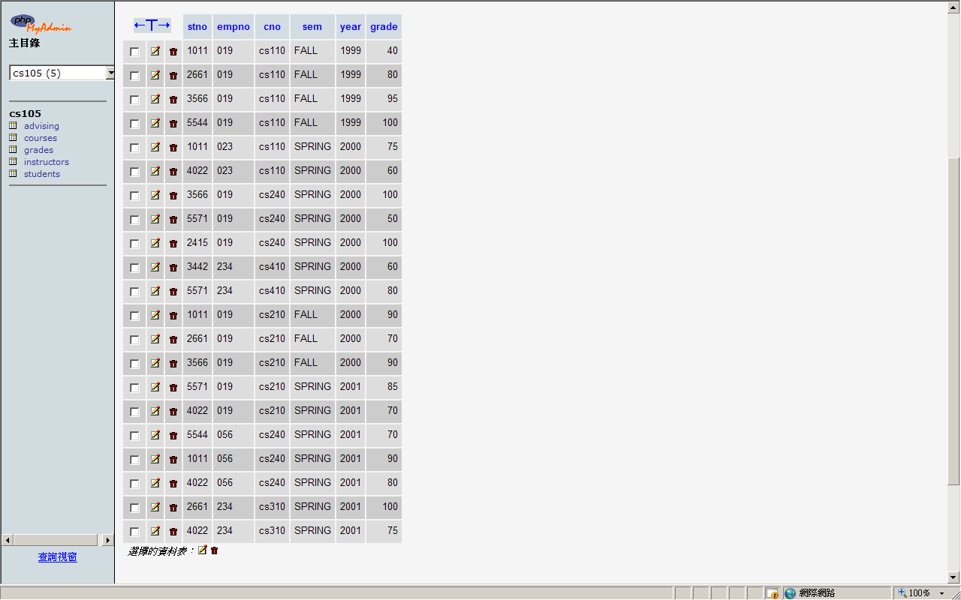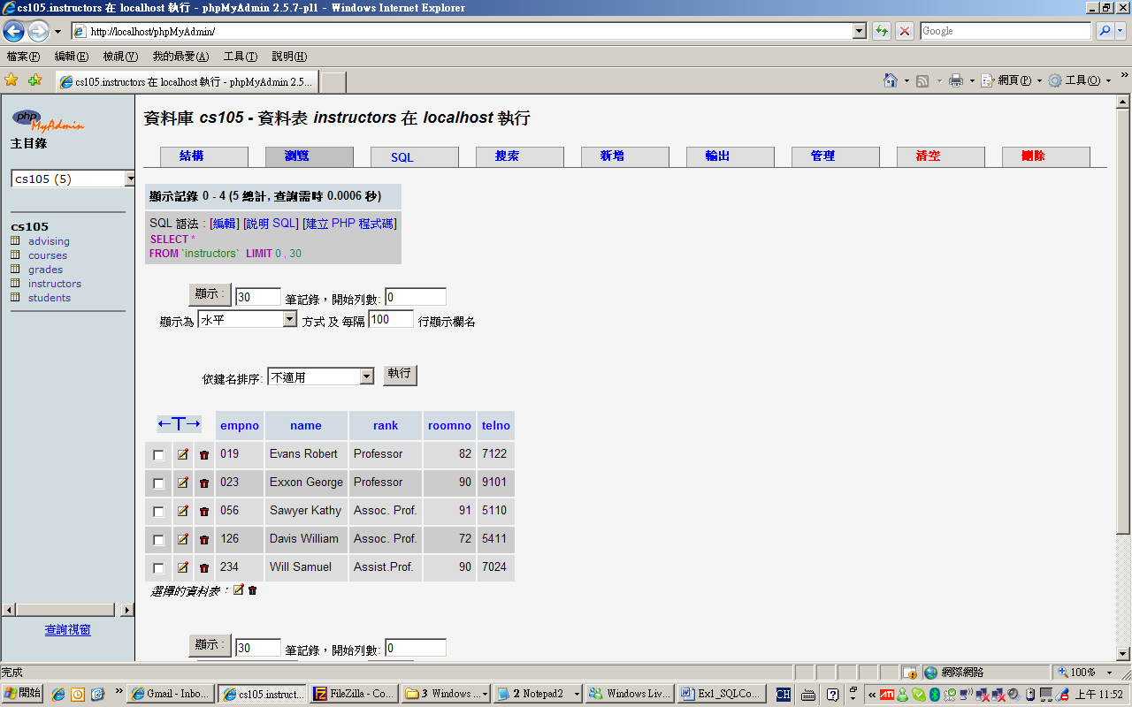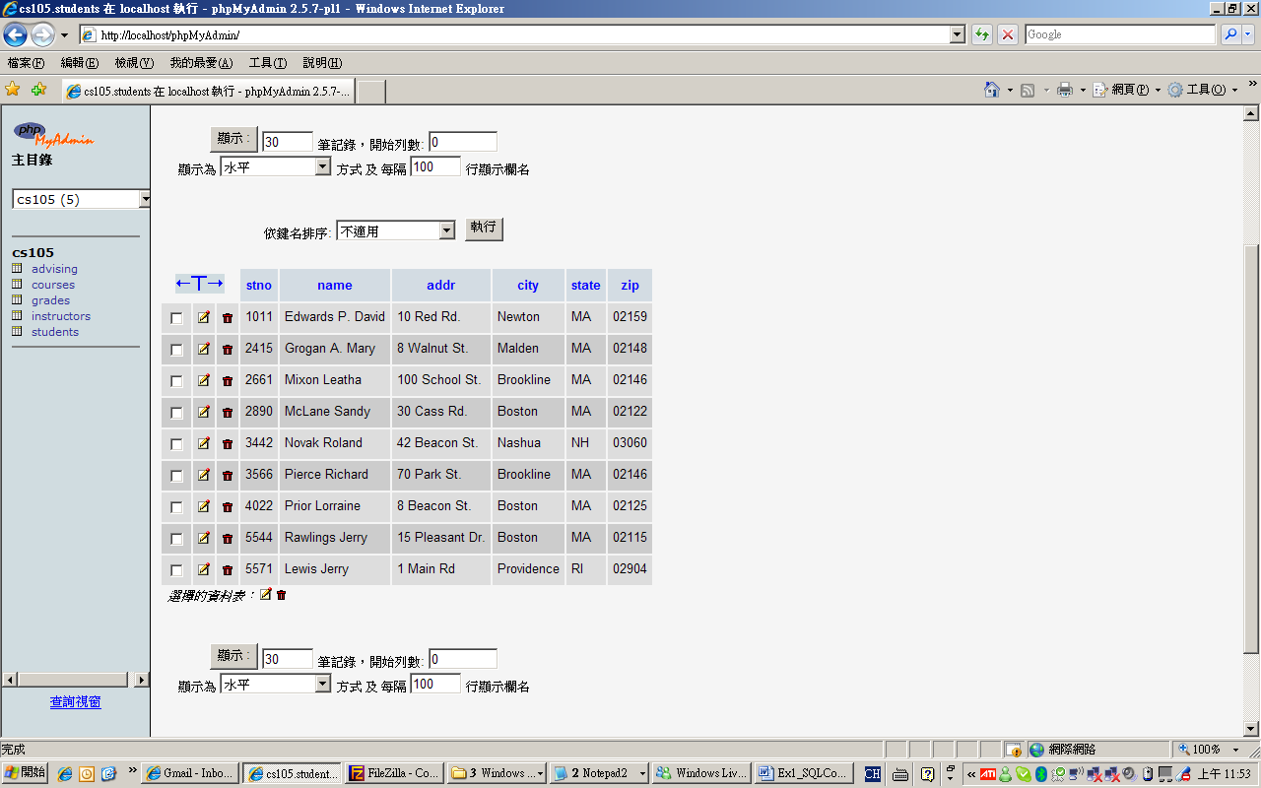
Advising
Courses
Grades
Instructors
Students

3.1 Write down the SQL command to show the names of instructors which are 3 credits.

3.2 Write down the SQL command to show the names of students who live in Newton or Brookline.

3.3 Write down the SQL command to show the names of students whose grades (in at least one course) are greater than 90.

4. The following is an xml document. Organize the tags and make the xml document a better organized one. (You should correct the xml if it is not well-formed)

<?xml version="1.0"?>
<catalog>
<book id="bk101">
<authors></authors>
<author>Gambardella, Matthew</author>
<author>Galos, Mike</author>
<title>XML Developer's Guide</title>
<genre>Computer<price></genre>
44.95</price>
<publish_date>2000-10-01</publish_date></book>
<description>An in-depth look at creating applications
with XML.</description>
<book id="bk102">
<author>Ralls, Kim</author>
<title>Midnight Rain</title>
<genre>Fantasy</genre>
<price>5.95</price>
<publish_date>2000-12-16</publish_date>
<description>A former architect battles corporate zombies,
an evil sorceress, and her own childhood to become queen
of the world.</description>
</book>

